**Java Phase 5 : Testing, Deployment and develops tools**

**10 days**

**Day 1 : 19-09-2022**

Testing :

Junit testing Unit testing

TestNG Integration testing

Selenium Testing Automation testing

Testing

Docker

CI and CD tool

Overview of Kubernetes Develops tool

AWS Overview Deployment

Testing :

Testing is use to find the defect or error or bugs in the application.

If we run any application using any technologies java, C#, python, C or C++ etc. indirectly we are testing that application.

Read a, b 10 20

Sum = a+b

Write b 30

Once we run the program then we have to provide the input and expect the output. If expectation and actual result match. Then we can say test pass else test fail.

Controller layer, model layer, bean layer, dao layer, resource layer, service etc.

Testing mean running the program without main method or functions.

Testing mainly divided into two types.

Black box testing : if we are black box tester then we need knowledge to how to run the application using command prompt or tool.

Input----------🡪 Logic/ Process--------🡪 Output

White box testing : if we are white box tester then we need knowledge about that technologies. Because we are writing test case to check the business logic.

Input ---🡪 Login/ Process -----🡪 Output

Under this option we can say manual testing or automation testing.

These testing we can do manually or we can take the help of automation testing tool inside a tool we can write script which is responsible to run those test cases.

Unit testing : Unit testing is part of STLC (Software Testing Life cycle). STLC is a part of SDLC(Software Development Life cycle).

Unit testing is process in which the smallest testable code or part of an application testing independently. Generally we write code inside function or method. Those method or function test independently working or not. Unit testing come under the type of white box testing.

jUnit : jUnit is an open source small testing framework which help to do the unit testing.

jUnit 3.x without annotation

jUnit 4.x with annotation

jUnit 5.x with annotation with combination of more other third party library.

TestNG

In Junit testing we will create test case and test suite.

Test Case : it is type of normal testing class which contains more than one test method with @Test annotation which help to test function functionality.

Using test case we can run more than one test function.

Test suite : Test suite is use to run more than one test case which contains more than one test function.

In Eclipse IDE by default they provided testing plugin for junit testing.

Testing hook : testing hook is like a life cycle testing method which will get call automatically before testing as well as after testing.

**Day 2 : 20-09-2022**

ProductDao

Using JDBC

Then we will test service layer and dao layer

MVC

Controller layer depends upon service layer

Service layer depends upon dao layer

Dao layer depends upon resource layer

Resource layer depends upon resources like database.

Service layer make the mock or fake or dumpy response for DAO layer.

Controller can make mock object for service layer

To achieve mocking mechanism we can have depends upon third partly library

Jmockito : we can configure jUnit with Jmockito to achieve mocking mechanism

We can run only one test case. That test case class can contains more then on test function.

Test suite is to execute more than one test case.

TestNG : It is open source light weighted testing framework base upon jUnit testing.

Test NG mean testing for next generation.

Using Test NG with combination of Selenium we can do automation testing.

Features

1. We can run parallel testing.
2. Using Test NG we can generate the report for testing result. By default it will generate in html format we can customer in our own format like xml or json etc.
3. It is easy to use compare to jUnit testing.
4. Using Test NG we can configure other develops tools like maven or gradle or Jenkin etc.
5. In Test NG we can make group to run more than one test function part of same file or different file.
6. We can run priority base testing.
7. TestNG is use to integration testing.

TestNG Project without Maven

TestNG Project with Maven

Day 3

21-09-2022

TestNG we can use annotation @Order to execute the test cases.

By default TestNG execute the test case in alphabetical order.

In TestNG we can create test suite using XML file. In that we can take the help of tag to control our test cases.

Group : we can add more than one test function belong to same test case class or different test case.

Day 4

22-09-2022

Selenium : Selenium is one the most widely used open source Web UI User interface automation tool.

Automation tool : it may be open source or paid tool which help to do the testing through GUI automatically base upon rules written in script file with help of some language.

Generally automation tools help to do the integration testing.

Soap UI

Selenium

Selenium provided features as WebDriver, Selenium Grid and Selenium IDE.

This tool supported by language like Java, C#, python, JavaScript etc.

This tool is browser independent.

This tool generally integrated with one of the testing framework in Java ie TestNG

We can configure this tool with devops : Docker, maven, git, Jenkin, Kubernetes, Agile etc

Selenium

SoapUI

PostMan

With help of Selenium we can do Web UI Testing. Selenium take the help of jUnit or TestNG which provided lot annotation like @Test, @BeforeMethod, @BeforestTest, @BeforeClass with more than assert methods.

Selenium is only responsible to load the web page ie static that is static or dynamic develop in any language and provided set of method to load the DOM element or html contents. To verify those content we have to depends upon TestNG or jUnit annotation.

If we are JS developer then for JS if want to do testing then we can depends on open source tool like Jasmine and Mocha. Jasmine is like a unit testing for JavaScript file or Mocha

Java -🡪 Junit JavaScript -🡪 jasmine

TestNG Mocha

Angular testing with help of Jasmine with Karma (Karma is test runner for Jasmine tool in Angular ).

React JS with JEST framework

We will do automation testing using Selenium with help of Web Driver

Selenium with TestNG

After Testing through Selenium IDE

We can do the Testing using Selenium IDE. It support GUI base Testing.

Docker :

Docker is an advanced OS Virtualization software platform which makes easy to create, deploy and run the application in Docker container.

What is means by Virtualization.

Virtualization means of employing software (such as hypervisor) to create a virtual version of resources such as database, server or application. Virtualization provide a features to run the application in virtual machine rather than installing software in physical machine.

VM ware software

Base Machine : Window 10 with RAM 16

VM ware --🡪 Linux, or Unix, Or Mac

4 GB or 50 GM

10 Guest OS

16 GM

1 GB

1 GB

1 Gb

Virtualization and Containerization

Virtualization is an abstract version of physical machine. Containerization is abstract version of application.

VM ware software help us to run virtual physical machine.

Docker is use to run the abstract version of an application.

Docker file : Docker file contains set of instruction which help to build the image.

Demo.java : we need to follow Java syntax to write the program.

Docker images : it is a template that hold set of instruction as well as configuration details which help to run the container.

Docker Container : this is a running process or running the instance of Docker images container turns the actual application or run the application.

docker --version : This command is use to give the version details about docker

docker images : This command is use do display all images present in local machine.

docker pull imageName : This command is use to pull the image from docker hub repository

26-09-2022

docker run imageName/imageId This command is use to run the image

First we have Docker hub account :

Docker hub is registry which help to pull and push user defined or pre-defined images.

To create user defined image we have to create the Dockerfile and then have to write the rules to run the application.

1. My Busy image to display custom message.

Dockerfile

FROM busybox:latest

CMD ["echo","Welcome to Docker user defined image with busybox"]

docker build -t my-busy-box . -f Dockerfile

Then check the images

1. Creating user defined image to display date with the help of alpine

Dockerfile

FROM alpine:latest

CMD [ "date" ]

docker build -t my-alpine . -f Dockerfile

1. Creating the image to run the Java Program
2. Creating the image to run the Spring boot application
3. Creating the image to run the angular application

Google provided pre defined server ie web server to run the angular application in port 4200. After develop the application we have to build the project. Please stop the project and

ng build command to build project

by default nginx server run on port number 80

if we want to push the image in Docker hub. First we have to connect our local machine terminal with Docker hub username and password

Before push we have to provide tag for the image.

docker tag my-angular-app akashkale/my-angular-app:1.0

After tag created successfully then you can push the image in Docker hub account

docker push akashkale/my-angualr-app:1.0

docker pull akashkale/my-angular-app:1.0

docker ps

or

docker container ls : it is use to display running containers

docker stop containerId/containerName it is use to start the container

docker start containerId/contaienrName it is use to stop the container

docker rm contaierId/containerName it is use to remove the container

or

docker rm contaierId/containerName –f : if you get the error not able to remove because container running then you can remove forcefully

docker system prune –a

If want to run more than one container and those container interacting with each others.

Like Spring boot application want to connect the mysql database.

My sql image

Myspring boot image

Network environment

Spring-boot-application mysql-image we pull and set username

Password and database name.

docker compose : Docker compose is a tool that was developed to help to defined and share more than one container application like Spring boot and mysql database. With docker compose concept we have to make YML file and inside this file we have to provide both images details and their network environment information. With help of docker compose we can up all container down, build, stop, start etc.

first create the spring boot application with controller, service, dao, bean

then in application.properties file write database details

server.port=9090

spring.datasource.driver-class-name=com.mysql.cj.jdbc.Driver

spring.datasource.url=jdbc:mysql://mysqldb/mydb

spring.datasource.username=root

spring.datasource.password=root

spring.jpa.hibernate.ddl-auto=update

mysqldb 🡪 host name

mydb 🡪 database name

root 🡪username

root -> password

hibernate ddl property 🡪 auto table creation.

Now using mvn package create the jar file.

When we run mvn package in spring boot initializer contains testing dependencies and that dependencies check database details. So to avoid this error we have to remove testing dependencies remove.

So please remove testing dependencies.

Then run the command as mvn package

After jar file created successfully.

Now we have to create the image for spring boot

Create the Dockerfile

**FROM** openjdk:11

**COPY** target/spring-boot-with-docker.jar .

**CMD** ["java","-jar","spring-boot-with-docker.jar"]

Then create the Docker image

docker build -t spring-boot-app . -f Dockerfile

Now create the docker-compose.yml file

version: "3.0"

services:

spring-demo:

image: spring-boot-app

ports:

- "9292:9090"

networks:

- spring-boot-mysql

depends_on:

- mysqldb

mysqldb:

image: mysql:8

networks:

- spring-boot-mysql

ports:

- "3308:3306"

environment:

- MYSQL_ROOT_PASSWORD=root

- MYSQL_DATABASE=mydb

networks:

spring-boot-mysql:

Then check the docker-compose –-version

docker-compose build : this command use to build the image

docker-compose up this command run both the images

docker-compose up –d This command is use to run both image in background

docker-compose down This command is use to stop all container through file.

To check the docker database

Run the below command with container name or containerId

docker exec -it 1748fb9e6d28 bash

After run the command as

mysql –u root –p

* Root

28-09-2022

CI and CD tool : Continuous Integration and Continuous Delivery or Deployment

Team 1 or Dev1

Team 2 or Dev2 Git hub CI/CD tool -🡪 Product server

Or testing server

Team 2 or Dev3

CI and CD tools

Jenkin

Gitlab

Bamboo

CircleCI

Jenkin : It is a type of open source CI and CD tool also known as Integration server. Which help to build the application, test the application and deploy the application. Jenkin develop using Java. It support by all OS. It is a plugin base CI and CD tools.

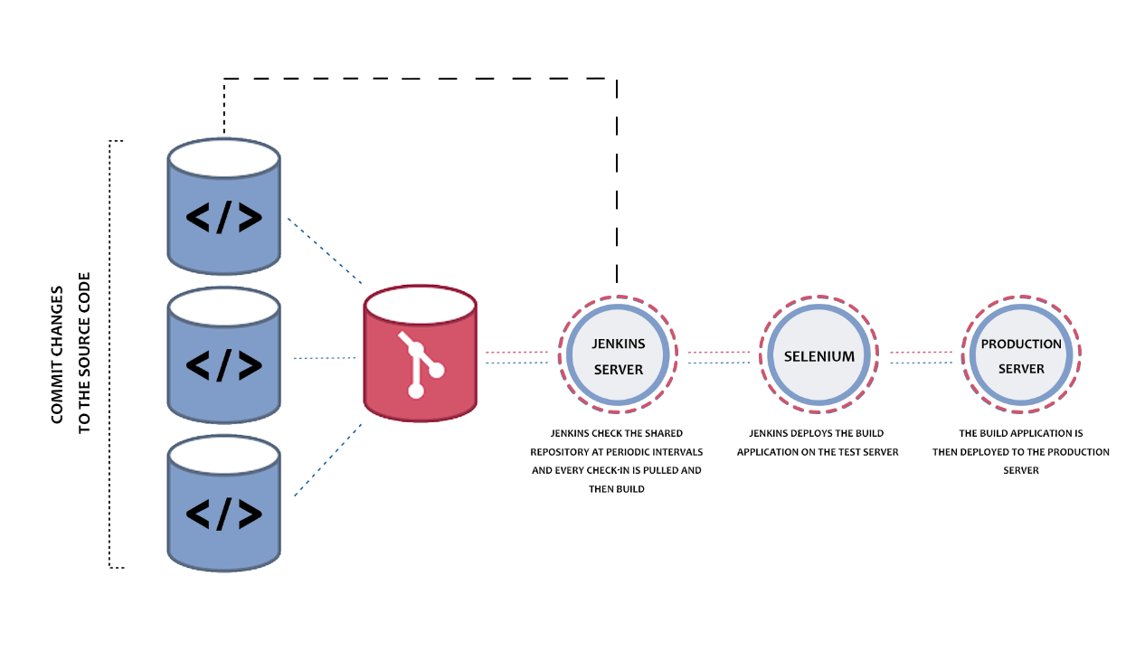

Jenkin Software

1. Using exe (Jenkin Software we have to install)
2. Using Jenkin.war file (we required external server ie tomcat or any web server)
3. Using Docker

This command pull the Jenkin image and run that image on port number 8080

docker run -p 8080:8080 -p 50000:50000 --restart=on-failure jenkins/jenkins:lts-jdk11

http://localhost:8080

docker run -p 8181:8080 -p 50000:50000 --restart=on-failure jenkins/jenkins:lts-jdk11

http://localhost:8181

Jenkin Pipeline Jenkin pipeline is a suite of plugins which help to execute set of jobs or task which are inter connected to each other in a sequence. Example build project, test the project, deploy the project.

Cloud computing

The cloud refer to network or internet. In other words we can say that cloud is something which is present in remote location and it provide service like database resources, virtual machine, storage, tools etc.

Cloud computing mainly divided into two types.

1. Deployment model

public cloud : External person or public

private cloud : within organization

hybrid cloud : combination of public and private

community cloud : lot of organization supporting for this type of cloud.

1. Service model

IaaS : Infrastructure As A Service

PaaS : Platform As A Service

SaaS : Software As A Service

AWS

Azure

Google cloud

SAP

Sales forces

Etc

S3 : It is a type service provided by AWS. S3 means Amazon Simple Storage Service which help to share the any type of data with an amazon account or group of account or public . We can apply different type of to access those data. We can store very huge data. S3 is like a google drive.

30-09-2022

EC2 : Amazon Elastic Compute Cloud : Amazon provide one of the predefined module ie EC2 which help create the Virtual machine of any type of OS ie can be window, linux or unix etc. which help to download required software and deploy the application.